  Our staff will greet you with a smile and a spear in hand!  Different Approaches for Different Arenas  We here at Rome, INC realize that there is no such thing as a one-size-fits-all plan to warfare. Here are some of the ways we’ve approached problems in the past.  - During the Punic Wars, we allied with small towns and cities to protect them from one big enemy (Carthage).  - In the Macedonian Wars, we held an alliance with Pergamum. This vastly more complicated land necessitated a strong, constant ally.
  Who We Are
  About Us
  We are the great protectors of the Western hemisphere! We protect our allies from the might of other, more antagonistic powers. We have a sterling track record of shielding our friends from trouble, from Pergamum to Saguntum. The world is a scary place; empires like Carthage and Macedonia skulk in the shadows, ready to add more territory to satiate their rapacious natures. We are there to help stop them and their ilk. So, if you’re a state in need of service, swing on over to our home office (don’t be intimidated by the size!) and we’ll see what we can do.
  DISCLAIMER: We will attack aggressors; we will NOT attack those who are not actively threatening potential clients. We are a family-friendly business after all.
  Contact Us
  Phone: 123-456-7890
  Email: punicschmunic@hotmail.com
  Web: romeisthehome.com
  Rome, INC
  1600 Empire Street
  Rome, Italy 00100
  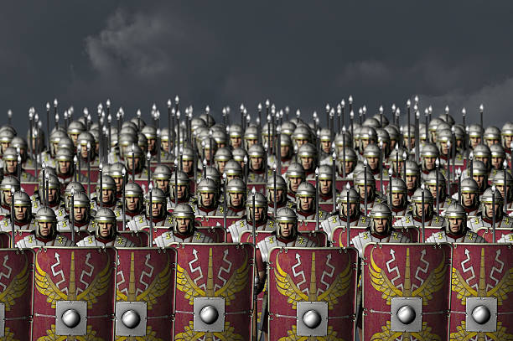
  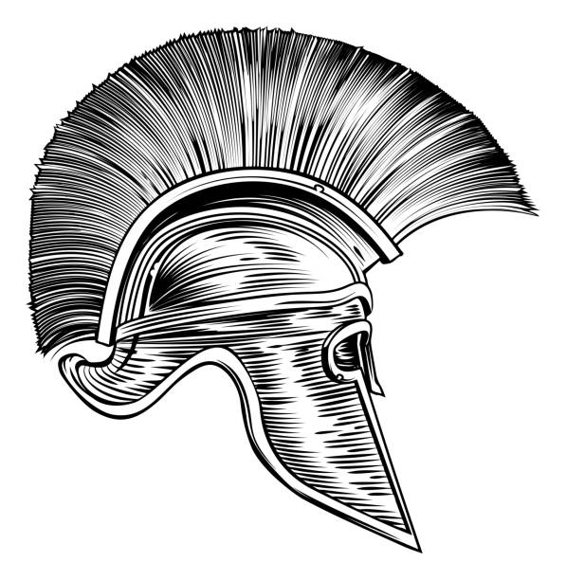
  Rome, INC
    - All defend, none attack. We will always have your back!

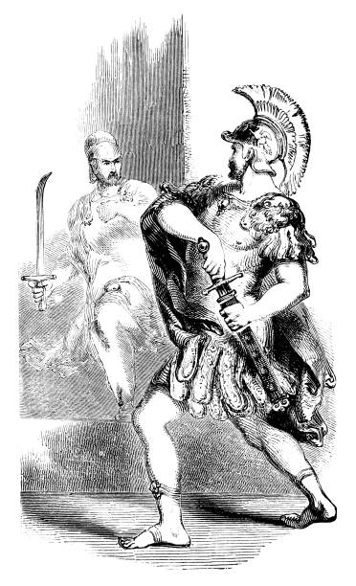  Why are you all not more aggressive?  Here are a couple of reasons…  - War is expensive – We Romans like to keep to our own lands, but the expenses brought on from defending our allies led us to create provinces that supply us with what we need to succeed  - War is labor-intensive – we had to increase our number of high officeholders just to keep up! |  |  | Are you sure that you all are not just building an empire under our noses?  We are not covert empire-builders, no sir. You will see, indeed, that our war-making efforts have been more start-and-stop than consistent. This is because we only commit to war to protect our clients.  “They delivered swift, restorative justice for us when we needed it most during the Macedonian Wars. I love Rome, INC!” - King Attalus I of Pergamum  As you see from the quote above, our clients are happy with our services, and we make sure to leave them as whole as when we found them! |  |  | 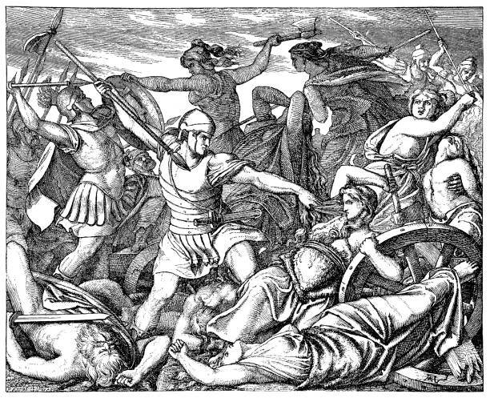  Our employees out in the field. Go get ‘em, boys!  Our Achievements  - We brought peace to the Greek world – without colonization!  - We defeated our hated rival, Carthage, three times in war – without taking them over!  - We have not advanced on our allies’ territory – we have kept states such as Pergamum and Numidia intact!  Sensing a theme? We are ultimately a peacekeeping power. We just want recognition as such. If you give us our due respect, direct payment won’t be necessary!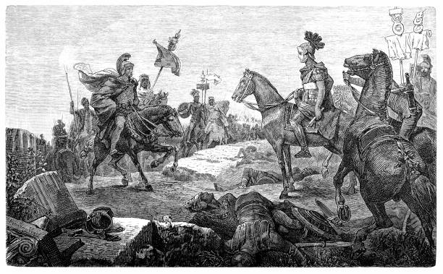
Artifact Thought Process and End Product
My goal with this artifact was to convince others that Rome was predominantly defensive in its overseas ventures. I figured that painting Rome as a friendly corporation whose services need to be sought out first would be ideal in establishing Rome’s passive nature. To bolster this image, I included a picture of a smiling Roman soldier. I also used the word “protect” much more than the word “attack.”
I made sure to list reasons why Rome would not want to actively pursue war other than for protective purposes. I noted that war was expensive for the Romans and that they had to establish provinces, a practice which necessitated a certain amount of oversight, to get supplies and other resources for conducting war. I wrote also that war was labor-intensive for the Romans. This is apparent not just in their management of provinces but also in their expansion of high offices.
The “Our Achievements” section of my pamphlet may be the most vital in conveying this idea of non-aggression. Carthage was defeated three times in three separate wars, but their empire was never taken over by the Romans. They helped to stabilize the eastern Mediterranean without taking any colonies. Most importantly, they kept allies such as Pergamum and Numidia intact without encroaching on their lands.
As this is a piece of propaganda, I made sure to emphasize Rome’s virtues and left out some details that may make Rome seem more “unjust” than it really was. Ultimately, I found that Rome’s actions were truly protective in nature.

