“Only a Game”

American Sport in Media & Culture

“It has long been my conviction that we can learn far more about the conditions and values of a society by contemplating how it chooses to play, to use its free time, to take its leisure, than by examining how it goes about its work.”
- Bart Giammatti

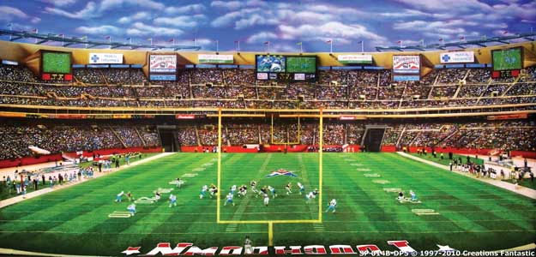

First-Year Seminar 142-3-A
Glatfelter 203: 11.25-12.40 T/F
Burg Hour: Glatfelter 203: 11.30-12.30

Professor Jack Ryan
Pennsylvania Hall 3rd Floor
X6820
jryan@gettysburg.edu
Office Hours: If you can’t reach me, please contact Kara Flythe <kflythe@gettysburg.edu>. Please feel free to contact me via email at any time; by phone during regular business hours.

Allison Schofield
Burg Partner
aschifie@gettysburg.edu
X6901

TEXTS
Sports in American Life: https://ebookcentral.proquest.com/lib/gettysburg/detail.action?docID=817330
(SAL)
Open Source Material
Films on Moodle Site
Podcasts
Blogs

PURPOSE
Designed to provide you with experience in the analysis of text & media as expressive, aesthetic mediums, this course uses American Sport as its primary area of intellectual analysis. The seminar will be all things to all people: a combination of technical analysis, literary discussion, cultural commentary, and writing workshops. Our aim is to answer a single overarching question, "Why is sport such an important part of American culture?" To this end, we will "read" essays, discuss them in a variety of ways, and examine their connection to sport. Organized sports have formed a major source of entertainment, economics, and political and personal identity for countless people.

A key assumption here is that formal analysis is a skill acquired through application and practice, so the writing load is significant; this will sharpen your critical eye and aid your communication skills. You will need to keep up with the deadlines, since to do otherwise will throw you off pace. There will be a steady workload throughout the semester: traditional papers, short assignments, an interview, presentations, and a larger presentation as a final examination.

This course is more akin to an English class in style of presentation of material. Because we are dealing with subjective source material, there are no “wrong” points of view, interpretations, or answers.

Ideas will be the currency of this class, and therefore attendance and participation will be crucial to your success. Sport in America is a cultural common, whether one pays attention to sports or not. On and around our various playing fields athletes, fans, and critics perform their identities, signify cultural values, and represent social issues. The sports page contains material that would interest scientists, sociologists, anthropologists, historians, painters, filmmakers, economists, and writers.

This class satisfies the first year Effective Communication requirement, and its subject matter makes it an ideal cluster class, a component of the Gettysburg Curriculum.

Getting Through:

Only a Game: “Only a Game” is a radio program located at this website: http://www.onlyagame.org/

The sport commentary is unusually erudite, and the staff always looks beyond the surface of all sports. I will encourage you to listen to this program; however, there will be weeks when listening will be required. It is, after all, the source for the course title.

Sport media coverage is dynamic, and therefore the reading, listening, and viewing content for this course will grow as the semester progresses. I will notify you when new material has been added to the syllabus, but it is your responsibility to stay current, too.

Papers: For the most part, you will be required to write expository papers. Your essays involve creating an argument that you will defend with text-based evidence. Keep in mind that you are making an argument for your interpretation of a text, not echoing what someone else has said. Therefore, your essays require an overriding point of view, which can be implied or stated directly, and supported by many sub points that uphold your idea--be sure to include solid examples in your work. Your written work will undergo a workshop process in class. Your essays will evolve as you commit yourself to composing drafts, which means you will revise your work, not just make cosmetic adjustments. Your essays need to be clear and precise, double-spaced, and include an original title. Each will be submitted electronically.

Grades: The merits of your individual work, including your level of participation and attendance will anchor your final grade. Your work and effort will all be included in this assessment. If you skip class, miss due dates, and ignore the assigned readings your grade will suffer. Rubrics will be provided for all your major, high stakes projects. Lower stakes projects, such as the weekly summaries, will be assessed on accuracy and clarity.

Learning Outcomes:
- To Refine critical reading skills
- To Develop discussion skills through classroom-based work
- To Develop writing and communication skills though revision and practice
- To Appreciate the broad cultural reach of sport
- To Consider alternative ways to view the world of sport
- To Distinguish between high-quality and weak research resources
- To Appreciate and consider unfamiliar topics

The 4th Credit Hour: You have arrived at Gettysburg College at a time when we faculty and students are required to interact for more time each week than had been customary practice. This change occurred nationwide. You will complete the 4th credit hour for this course by engaging in our Thursday sessions, listening to Only A Game, podcasts, watching films, and attending an occasional special event that I will designate during the course of the semester.

Attendance: The class will proceed mostly in a read and discuss format. Thus, to participate and receive credit for participation and ultimately engage the subject matter, you will need to be in class. If you know you are going to miss more than one class, please contact Academic Advising, a great resource in the time of a personal or family emergency. As an official guideline for attendance, please be aware of the following policy: More than three absences during the semester will result in the loss of 5% of your overall grade; more than four absences, 7.5%; and more than five, 10%. I reserve the right to make further grade reductions.

The Honor Code: The Honor Code is an integral part of the College’s culture. Please use the Honor Code on all your assignments. In a class like this one, plagiarism will not be tolerated.

Grading:

Participation Attendance: 10% (this includes small, low stakes assignments)
Midterm Exam: 10% (this will be a take-home writing assignment)
Assignment One: 10% (this includes drafts and in-class revision session)
Interview Assignment: 15% (this includes in-class presentation)
Assignment Two: 15% (this includes one in-class revision session)
Assignment Three: 10% (this includes drafts and in-class revision session)
Assignment Four: 10 % (this includes drafts and in-class revision session)
Assignment Five: 20% (this includes in-class presentation)

Resources:
Gettysburg College Writing Center: http://www.gettysburg.edu/academics/english/student/writing-center.dot

Gettysburg College Counseling Services: http://www.gettysburg.edu/about/offices/college_life/counseling/index.dot

Gettysburg College Office of Academic Advising:
http://www.gettysburg.edu/about/offices/provost/advising/index.dot

Purdue University Writing Lab: https://owl.purdue.edu/index.html

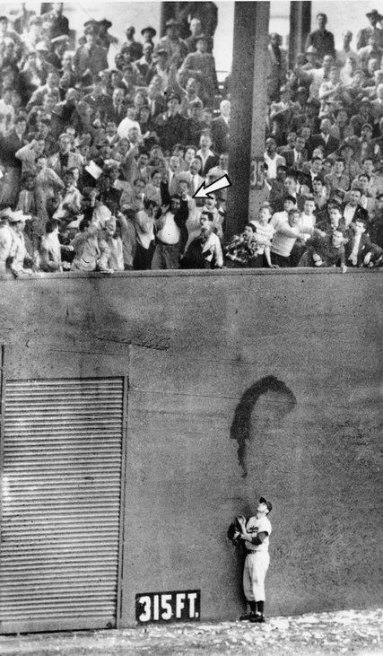

SCHEDULE

Fall 2019

Week One
Skin in the Game
27 August: Introduction: The Sports Column
BURG: 29 August
30 August: SAL Chapter One: Sports Column Due
Thursday Burg: Gettysburg College Mission Statement/Activities Fair

Week Two

3 September: Read Chapter 11, view View: John Oliver, “Last Week Tonight: The NCAA.”
https://www.youtube.com/watch?v=pX8BXH3SJn0
Exercise: Find a newspaper or magazine article detailing the debate about paying college athletes. Write a one-page brief on the pros and cons of paying college athletes. Bring to class as a hard copy on 6 September.

BURG: 5 September, Sport Communications & Well-Being
6 September: Read Chapter 7 and https://ussporthistory.com/2018/12/18/sport-and-society-fbs-nhlbs-and-nflbs/ and http://www.chronicle.com/article/Professors-Are-Complicit-in/241521

The College Game (assignment one)

Week Three

10 September: Read Chapters 6 & 15. Listen: https://www.wbur.org/onlyagame/2017/10/13/october-14-2017-oag
Exercise: After listening to the “Only A Game” episode, please respond to the questions embedded in the course Moodle site. Bring your responses to class.

BURG: 12 September: Meetings. With Allison

13 September: NO CLASS. Meetings with Allison. Read https://ussporthistory.com/2017/08/14/how-does-title-ix-affect-sexual-assault-prevention-in-college-sports-a-critical-review-of-the-dear-colleague-letter-of-2011/
https://www.nytimes.com/2019/09/05/sports/ncaafootball/jalen-hurts-graduate-transfer-quarterbacks.html

Title IX: 21st Century Implications (assignment two)

Week Four

17 September: https://www.insidehighered.com/news/2019/09/11/california-passes-bill-allowing-athletes-be-paid-name-image-and-likeness?utm_source=Inside+Higher+Ed&utm_campaign=17b4402243-WNU_COPY_01&utm_medium=email&utm_term=0_1fcbc04421-17b4402243-197460505&mc_cid=17b4402243&mc_eid=e4b5464448

https://www.chronicle.com/article/California-Is-Poised-to/247125?utm_source=pm&utm_medium=en&cid=pm&source=ams&sourceId=352812

https://www.npr.org/2019/09/11/759699248/california-could-radically-alter-amateur-rules-in-the-state-s-college-sports
Assignment One Draft Due: The Argument For or Against Compensation for college athletes
BURG: 19 September, Time Management
20 September: https://www.nwlc.org/sites/default/files/pdfs/nwlcathletics_titleixfactsheet.pdf
https://www.youtube.com/watch?v=Vx0714i-fDg
Assignment One Due: The Argument For or Against Compensation for college athletes

The Coach (interview assignment)

Week Five

24 September:
https://hbr.org/2009/01/what-can-coaches-do-for-you
http://www.newsweek.com/four-sportswriters-uconns-coach-geno-auriemma-443950
“Antonio Brown Saga. Just Another Sign of the Patriot Way,” New York Times 9.24.19
https://www.nytimes.com/2019/09/23/sports/antonio-brown-patriots-nfl.html
BURG: 26 September, First-Year Reading: bring the book to class!
27 September: Coach Interview Subject Due

The Gettysburg Profile (assignment three)

Week Six

1 October: https://www.chronicle.com/article/California-s/247255?utm_source=at&utm_medium=en&cid=at&source=ams&sourceId=352812

BURG: 3 October, Joyce Galanti

4 October: Assignment Two Due: An Examination of Title IX
https://www.nytimes.com/2019/10/02/sports/california-college-athletes-paid-ncaa.html

Week Seven

8 October: Chapter 10
BURG: 10 October, Schmucker Art Gallery
11 October: No Class: Screen “Not Just a Game” (This film is on Moodle).
Chapter 14
Respond to the exercise questions embedded on the Moodle site. Bring your responses to class on 18 October.

Week Eight

14 October: Reading Day: No Class
BURG: 17 October, TBD
18 October: Coach Interview Due/Presentations
https://www.nytimes.com/2019/10/04/arts/montreal-skateboard-anti-olympics.html

Week Nine

22 October: Coach Presentations
BURG: 24 October, StrenghtsQuest
25 October: Coach Presentations

Sport Photography (assignment four)

Week Ten

29 October: Portrait Exercise Discussion
https://www.nytimes.com/2019/10/24/sports/baseball/brandon-taubman-fired-astros.html?searchResultPosition=1

BURG: 31 October, Green Dot Booster

http://www.edgeofsports.com/2017-10-16-1299/index.html
http://www.edgeofsports.com/2017-10-19-1300/index.html
http://www.edgeofsports.com/2017-10-25-1301/index.html
http://www.edgeofsports.com/2017-10-30-1302/index.html
1 November: https://www.nytimes.com/2019/10/30/opinion/NCAA-pay-athletes.html?searchResultPosition=2

Reserach Project (assignment five)

Week Eleven

5 November: https://www.theringer.com/2019/10/11/20909171/california-sb-206-ncaa-pay-college-players
https://www.newyorker.com/culture/cultural-comment/the-ham-handed-money-driven-mangling-of-sports-illustrated-and-deadspin?source=EDT_NYR_EDIT_NEWSLETTER_0_imagenewsletter_Daily_ZZ&utm_campaign=aud-dev&utm_source=nl&utm_brand=tny&utm_mailing=TNY_Daily_110419&utm_medium=email&bxid=5bd66ec02ddf9c619438684f&cndid=20592334&esrc=&mbid=CRMNYR062419&utm_term=TNY_Daily
https://www.walteriooss.com
https://the1a.org/shows/2019-10-31/changing-the-game-ncaa-opens-the-door-for-athletes-to-profit

BURG: 7 November Career Engagement

8 November: No Class—Northeast Deans Meeting

Week Twelve

12 November:

BURG: 14 November

15 November:

Week Thirteen

19 November: Photography Essay Due
20 NOVEMBER THANKSGIVING DINNER
BURG: 21 November
22 November:

Week Fourteen

26 November:
Thanksgiving Break

Week Fifteen

3 December:

BURG: 5 December

6 December: (Research Project Due)

Final examination: Research Presentations & Reports: Tuesday 10 December 8.30AM-11.30AM

Resources
http://www.edgeofsports.com/index.html
https://www.theplayerstribune.com
https://www.sbnation.com
http://theundefeated.com
http://www.wbur.org/onlyagame
http://www.tidesport.org
https://www.si.com/nfl/2017/09/13/colin-kaepernick-jersey-bills-jets-game-tim-rohan
http://www.sportsonearth.com
https://www.theringer.com/
http://www.blupete.com/Literature/Essays/Hazlitt/Fight.htm
https://stars.library.ucf.edu/onsportandsociety/
http://www.sandiegouniontribune.com/sdut-another-legal-headache-at-penn-state-title-ix-2012aug29-story.html
http://www.gettysburgsports.com/staff.aspx
https://www.nytimes.com/2016/05/30/sports/ncaabasketball/once-disgraced-mike-rice-finds-redemption-in-youth-basketball.html?action=click&contentCollection=College%20Basketball&module=RelatedCoverage&region=EndOfArticle&pgtype=article
https://www.youtube.com/watch?v=52YIen9A_dc
https://www.nytimes.com/2017/09/26/sports/ncaa-adidas-bribery.html?action=click&contentCollection=Sports&module=RelatedCoverage&region=EndOfArticle&pgtype=article
https://www.si.com/college-basketball/2017/09/28/rick-pitino-career-louisville-kentucky-fbi-scandal
https://www.si.com/nfl/2017/09/25/anthem-protest-donald-trump-colin-kaepernick
https://www.si.com/college-basketball/2017/09/29/college-basketball-corruption-scandal
http://www.edgeofsports.com/2017-10-03-1293/index.html
https://www.nytimes.com/2017/10/04/sports/football/dale-hansen-nfl-wfaa.html?rref=collection%2Fsectioncollection%2Fsports&action=click&contentCollection=sports&region=rank&module=package&version=highlights&contentPlacement=8&pgtype=sectionfront&_r=0
http://www.slate.com/articles/sports/sports_nut/2017/09/what_s_wrong_with_the_u_s_men_s_national_soccer_team_and_how_to_fix_it.html
http://bleacherreport.com/articles/2739599-the-28-point-plan-for-fixing-mens-soccer-in-america

